**LECTURE 1**

**WHAT IS SYSTEM DESIGN?**

The start of the system development process(Before the programming) A way to understand the problem before you solve it. A way to understand and communicate what a client needs to be done.

It is a process of collecting and interpreting facts, identifying the problems, and decomposition of a system into its components.

System analysis is conducted for the purpose of studying a system or its parts in order to identify its objectives. It is a problem solving technique that improves the system and ensures that all the components of the system work efficiently to accomplish their purpose.

**WHY DO WE NEED SYSTEM ANALYSIS?**

1. Problem identification and definition: System analysis helps in identifying and defining problems within a system. By analyzing the existing system, its processes, and its objectives, analysts can determine the areas that require improvement or optimization.
2. Requirement gathering: System analysis enables the collection and documentation of user requirements. By interacting with stakeholders, understanding their needs, and analyzing the existing system, analysts can define the functional and non-functional requirements for the new or improved system.
3. Process improvement: System analysis helps in identifying inefficiencies, bottlenecks, or redundant processes within a system. By analyzing the current workflow, analysts can propose changes or enhancements to optimize the system, increase productivity, reduce costs, or improve overall efficiency.
4. Design and planning: System analysis provides the foundation for system design and planning. By understanding the existing system and its requirements, analysts can create a blueprint for the new system, including its structure, components, interfaces, and functionalities. This design serves as a guide for developers, ensuring that the final system meets the desired objectives.
5. Risk assessment and mitigation: System analysis allows for the identification and evaluation of potential risks associated with the system. By examining the system components, dependencies, and potential failure points, analysts can assess the risks and propose mitigation strategies to ensure system reliability, security, and robustness.
6. Decision-making support: System analysis provides valuable insights and data that support informed decision-making. By analyzing different system alternatives, their costs, benefits, and trade-offs, decision-makers can make informed choices about system implementation, upgrades, or changes.
7. System integration: In complex environments, systems often need to integrate with other systems or interfaces. System analysis helps in understanding the requirements and constraints of integration, ensuring compatibility, data exchange, and interoperability between different systems.
8. System evaluation: System analysis allows for the evaluation of system performance and effectiveness. By defining appropriate metrics and measurement criteria, analysts can assess whether the system meets the desired goals and objectives, and identify areas for further improvement.

* The key indicators of project success (and project failure if they are not) are:
  + User Involvement
  + Executive Management Support
  + Clear Statement of Requirements

**WHEN PROJECTS FAIL…**

* It’s not about the money lost or the time wasted; remember that software is everywhere
* Financial losses: Failed projects often result in financial losses for the organization. Investments made in the project, including re sources, materials, equipment, and labor, may go to waste. Additionally, there may be additional costs associated with project termination or cleanup.
* Missed deadlines: Projects that fail often experience delays or miss their scheduled completion dates. This can have ripple effects on other dependent projects, leading to a cascading effect of delays throughout the organization.
* Damaged reputation: Project failure can damage the reputation of the organization, especially if it becomes public knowledge. It can erode trust among stakeholders, customers, and investors, leading to a negative perception of the organization's capabilities and reliability.
* Employee morale and motivation: Failed projects can have a negative impact on employee morale and motivation. Team members may feel demoralized, frustrated, or disengaged due to the perceived waste of their efforts and resources. This can affect overall productivity and employee retention.
* Loss of opportunities: Project failure can result in missed opportunities for growth, expansion, or innovation. Failed projects may have been intended to capture new markets, develop new products, or improve operational efficiency. When these objectives are not met, the organization may lose its competitive edge or miss out on potential advantages.
* Legal and contractual implications: Depending on the nature of the project, there may be legal and contractual implications associated with its failure. Breach of contracts, non-compliance with regulations, or failure to meet contractual obligations can lead to legal disputes, financial penalties, or damaged relationships with suppliers or partners.
* Lessons learned and improvement: Despite the negative consequences, project failure can also be an opportunity for learning and improvement. It allows organizations to identify the root causes of failure, analyze what went wrong, and implement corrective measures for future projects. This experience can lead to better project management practices, risk mitigation strategies, and enhanced decision-making processes.

**WHAT IS A SYSTEM?**

It means an organized relationship between any set of components to achieve some common cause or objective.

A system is “an orderly grouping of interdependent components linked together according to a plan to achieve a specific goal.”

**WHAT IS AN INFORMATION SYSTEM?**

An information system is a means of catering for the flow and storage of information to satisfy the requirements of all users. As well as storing data it typically generates, manipulates and communicates information.

Examples of information systems

* CampusMoodle
* A website
* A payroll system
* An order processing system
* An expert system that diagnoses illnesses

**COMPONENTS OF AN INFORMATION SYSTEM**

1. Software
2. Hardware
3. People
4. Procedures/rules
5. Database
6. Documentation

**WHAT DOES A SYSTEM ANALYST DO?**

Translates users information needs into instructions for programmers to follow.

1. Requirement gathering and analysis: System analysts interact with stakeholders, such as end-users, managers, and executives, to understand their requirements and needs. They conduct interviews, workshops, and surveys to gather information about existing processes, pain points, and desired improvements. They then analyze these requirements to identify the functionalities and features that the system should have.
2. System design and planning: System analysts contribute to the design and planning phase of a project. They create system models, diagrams, and specifications that outline the structure, components, interfaces, and functionalities of the proposed system. They collaborate with other stakeholders, such as developers and designers, to ensure the system design aligns with the business objectives and technical feasibility.
3. Feasibility assessment: System analysts evaluate the feasibility of proposed projects or system enhancements. They analyze technical, operational, economic, and scheduling factors to determine if the project is viable and worth pursuing. They assess potential risks, benefits, costs, and impacts to make recommendations on whether to proceed with the project.

It develops and maintains an information system,

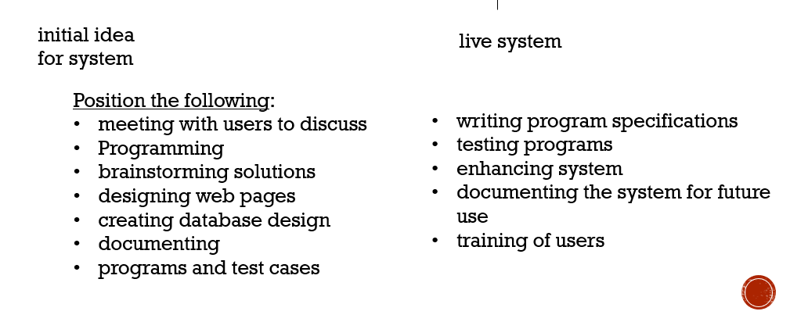

**WHAT KIND OF KNOWLEDGE MUST A SYSTEM ANALYST HAVE?**

1. Business and domain knowledge: A systems analyst needs to have a solid understanding of the business or industry they are working in. They should be familiar with the organization's goals, processes, and challenges. This knowledge helps them align the system requirements with the business objectives and ensures that the proposed solutions meet the specific needs of the domain.
2. Systems and technology knowledge: A systems analyst should have a strong understanding of various systems, technologies, and software development methodologies. They need to be familiar with both existing and emerging technologies, as well as their potential applications and limitations. This knowledge helps them assess the feasibility of technical solutions and make informed recommendations.
3. Requirements engineering: Systems analysts must be proficient in requirements engineering, which involves gathering, documenting, and analyzing user requirements. They should understand techniques for requirement elicitation, modeling, and validation. They should be able to effectively communicate and collaborate with stakeholders to ensure that the system requirements are accurately captured and understood.
4. System design and architecture: A systems analyst should have knowledge of system design principles and best practices. They should understand how to translate user requirements into a well-designed system architecture. This includes knowledge of system modeling techniques, database design, interface design, and integration methods.
5. Project management: Systems analysts often work within project teams, so they should have a basic understanding of project management concepts and methodologies. This includes knowledge of project planning, scheduling, risk management, and change management. They should be able to contribute to project planning and work collaboratively with project managers and team members.
6. Communication and interpersonal skills: Effective communication is crucial for a systems analyst. They should be able to communicate clearly and effectively with both technical and non-technical stakeholders. They should have strong listening skills to understand user requirements and be able to convey complex technical concepts in a understandable manner. Additionally, interpersonal skills are important for building relationships, facilitating collaboration, and managing conflicts.
7. Analytical and problem-solving skills: Systems analysts need strong analytical and problem-solving skills to identify system issues, analyze complex problems, and propose effective solutions. They should be able to think critically, break down complex problems into manageable components, and use logical reasoning to evaluate alternative solutions.
8. Documentation and technical writing: Systems analysts should have good documentation and technical writing skills. They need to document system requirements, design specifications, test plans, and other project artifacts. Clear and concise documentation is essential for knowledge transfer, system maintenance, and future reference.

**WHAT TYPES OF SKILLS MUST A SYSTEM ANALYST HAVE?**

1. Analytical and Problem-Solving Skills: Systems analysts need strong analytical skills to understand complex systems, identify issues or inefficiencies, and propose effective solutions. They should be able to break down problems into manageable parts, analyze data and information, and apply critical thinking to evaluate alternative options. Having strong problem-solving skills allows them to devise creative and practical solutions to meet the requirements of the system and address the challenges faced by the organization.
2. Communication and Interpersonal Skills: Effective communication is vital for systems analysts as they interact with various stakeholders, including end-users, managers, developers, and other team members. They need to listen actively, ask clarifying questions, and communicate technical information in a clear and concise manner. Strong interpersonal skills enable them to build relationships, facilitate collaboration, and navigate different perspectives and opinions. The ability to communicate complex technical concepts to non-technical stakeholders is also essential.
3. Technical Proficiency: Systems analysts should have a solid understanding of relevant technical areas, such as software development methodologies, programming languages, databases, and system architectures. While they may not need to be experts in every technology, having a good grasp of the technical aspects allows them to effectively communicate with developers, understand technical constraints, and evaluate the feasibility of proposed solutions. Technical proficiency also enables them to contribute to system design, make informed recommendations, and bridge the gap between business needs and technical implementation.
4. Communication skills: Effective communication is a crucial skill for a systems analyst. They need to communicate with stakeholders, developers, and other team members to gather requirements, convey technical information, and facilitate collaboration. Strong verbal and written communication skills, along with active listening skills, are essential for understanding user needs and conveying complex concepts in a clear and understandable manner.
5. Problem-solving and critical thinking: Systems analysts should have strong problem-solving and critical thinking skills. They need to be able to analyze complex problems, think logically, and propose innovative solutions. They should be able to identify root causes, evaluate alternatives, and make informed decisions to address system-related issues.
6. Collaboration and teamwork: Systems analysts often work within project teams, so the ability to collaborate and work effectively with others is crucial. They should be able to build positive relationships, foster teamwork, and communicate ideas and requirements to team members. They should also be able to work collaboratively with stakeholders from different backgrounds and with varying levels of technical knowledge.

**WHO DOES SYSTEM ANALYST WORK WITH?**

1. End-users: System analysts interact with end-users to understand their requirements, gather feedback, and ensure that the system meets their needs. They may conduct interviews, workshops, or user surveys to gather insights and validate system functionality.
2. Business stakeholders: Systems analysts collaborate closely with business stakeholders, including managers, executives, and subject matter experts. They work together to define project goals, align system requirements with business objectives, and ensure that the proposed solutions support the organization's strategic vision.
3. Project managers: System analysts often work within project teams led by project managers. They collaborate with project managers to define project scope, schedule, and deliverables. They provide input on resource requirements, risk assessment, and change management processes.
4. Developers and programmers: Systems analysts work closely with developers and programmers to ensure that the system design is effectively implemented. They collaborate in translating user requirements into technical specifications, addressing any questions or clarifications, and conducting system testing and debugging.
5. Quality assurance and testing teams: Systems analysts collaborate with quality assurance and testing teams to define test plans, scenarios, and acceptance criteria. They work together to ensure that the system meets quality standards, identify and resolve defects or issues, and validate system functionality.
6. System architects and designers: Systems analysts may collaborate with system architects and designers to create a well-designed system architecture. They work together to define system components, interfaces, and integration points, ensuring that the system design aligns with the business requirements and technical feasibility.
7. IT support and operations teams: System analysts work with IT support and operations teams to ensure a smooth transition from development to production. They provide documentation, training materials, and user support to assist in system deployment and address any operational concerns or issues.
8. Vendors and external partners: In some cases, systems analysts may work with external vendors or partners who provide specialized systems or services. They collaborate to evaluate vendor solutions, define integration requirements, and ensure that the external systems align with the organization's needs.

**Systems**

**Analyst**

Project

Manager

Internal

Audit

Team

Members

Senior

Management

IT

Management

Related Project

Managers

Communications

Operations

Data

Management

Clients

Users